 | NATIONAL UNIVERSITY  OF COMPUTER & EMERGING SCIENCES  PESHAWAR CAMPUS | 

Student Name: Ahmed Ali Roll No: P19-0042 Sec: 5B

Problem Set : Implement 01 Semester : FALL 2021
Date Set : Monday December 20, 2021 Due Date : Friday Dec.24, 2021
Course : CS301 Theory of Automata Instructor: Shakir

language :

L = {aibj | i,j > 0 and i ≠ j}

Descriptive Definition:
The number of a’s are followed by unequal number of b’s.

Words:
L = {abb, aab, aaab, abbb, aaaab, aaabb, aabbb, abbbb ......}

Turing machine

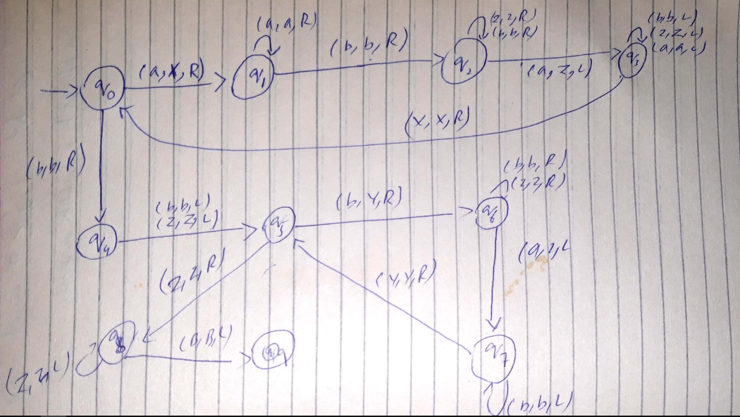

Code

def action(inp, rep, move):
global tapehead
if tape[tapehead] == inp:
tape[tapehead] = rep
if move == 'L':
tapehead -= 1
else:
tapehead += 1
return True
return False

tape = ['B']*50
string = input("Enter a string: ")
i = 5
tapehead = 5
for s in string:
tape[i] = s
i += 1

state = 0
a, b, c, d, X, Z, U, V, R, L, B = 'a', 'b', 'c', 'd', 'X', 'Z', 'U', 'V', 'R', 'L', 'B'
oldtapehead = -1
accept = True
while(oldtapehead != tapehead):
oldtapehead = tapehead

if state == 0:
if action(a, X, R):
state = 1
elif action(b, b, R):
state = 4

elif state == 1:
if action(a, a, R):
state = 1
elif action(b, b, R):
state = 2

elif state == 2:
if action(b, b, R) or action(Z, Z, R):
state = 2
elif action(a, Z, L):
state = 3

elif state == 3:
if action(b, b, L) or action(Z, Z, L) or action(a, a, L):
state = 3
elif action(X, X, R):
state = 0

elif state == 4:
if action(b, b, L):
state = 5
elif action(Z, Z, L):
state = 5

elif state == 5:
if action(Z, Z, R):
state = 8
elif action(b, Y, R):
state = 6

elif state == 6:
if action(Z, Z, R) or action(b, b, R):
state = 6
elif action(a, Z, L):
state = 7

elif state == 7:
if action(b, b, L) or action(Z, Z, L):
state = 7
elif action(Y, Y, R):
state = 5

elif state == 8:
if action(Z, Z, L):
state = 8
elif action(B, B, L):
state = 9
else:
accept = False

if accept:
print("Accept the string")
else:
print("Reject the string")

